

Maxim Merry School
Affiliated to CBSE (code: 1631028)
Tradition of excellence since 2001

Curriculum
&
Instructions

SESSION 2026-27
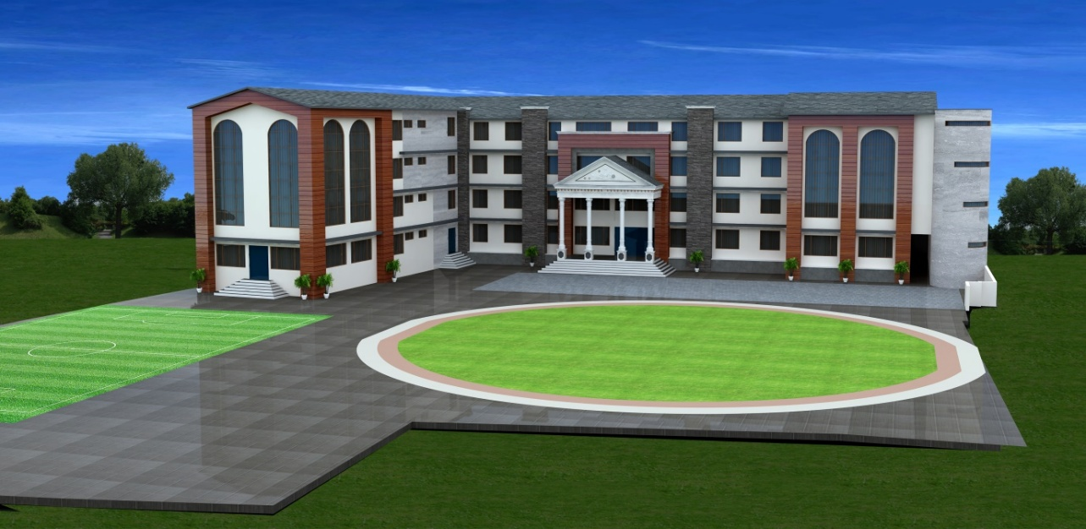

CLASS L.K.G
chool

Annual Syllabus
Session 2026-27
Subject: English
SR. NO. | MONTH | TOPIC
1 | April | Capital Cursive letters – A-B  - Oral- Recognition of cursive letters-A-B  • Phonic sounds of letter-A-B  • Vocabulary of letters-A-B  • Writing of cursive letter-A-B
2 | May | Capital Cursive letters – A-H  • Oral-Recognition of cursive letters- A-H  • Phonic sounds of letter- A-H  • Vocabulary of letters- A-H  • Writing of cursive letters- A-H
3 | July | Capital Cursive letters – A-M  • Recognition of cursive letters-A-M  • Phonic sounds of letter-A-M  • Vocabulary of letters-A-M  • Writing of cursive letters-A-M
4 | August | Capital Cursive letters – A-R  • Recognition of cursive letters-A-R  • Phonic sounds of letter-A-R  • Vocabulary of letters-A-R  • Writing of cursive letters-A-R
5 | September | Capital Cursive letters – A-Z  • Recognition, Phonic sounds, Vocabulary, formation of letters-A-Z  • Revision of letters-A-Z  - Concepts of letters (Matching, See and write, circle the letter etc)
6 | October | Capital Cursive letters – A-Z (Mid Term Assessment)  • Oral Assessment -Recognition, Phonic sounds, Vocabulary of letters-A-Z.  • Written Assessment-  • Writing of capital cursive letters-A-Z.  • Match the letters with picture.  • See the picture & write the letter.  • Circle the correct letter.
7 | November | Small Cursive letters – a-p  • Recognition, Phonic sounds, Vocabulary, formation of letters- a-p
8 | December | Small Cursive letters – q- z  • Recognition, Phonic sounds, Vocabulary, formation of letters- q- z
9 | January | Capital Cursive letters A-Z  Small Cursive letters – a- z  - Recognition, Phonic sounds, Vocabulary, formation of letters-Aa-Zz
10 | February | - Revision of all syllabus

Subject: Maths
SR.NO. | MONTH | TOPIC
1 | April | Numbers-1-2  • Recognition of numbers-1-2  • Writing of numbers-1-2
2 | May | Numbers-1-10  • Recognition of numbers-1-10  • Writing of numbers-1-10
3 | July | Numbers-1-30  • Recognition of numbers-1-30  • Writing of numbers-1-30
4 | August | Numbers-1-50  • Recognition of numbers-1-50  • Writing of numbers-1-50
5 | September | Numbers-1-50  • Revision of Recognition & Writing of numbers-1-50  - Concepts of numbers(Matching, count & write, missing numbers etc)
6 | October | Numbers-1-50 (Mid Term Assessment)  • Oral Assessment –Recognition & counting of numbers- 1-50  • Written Assessment-  • Writing of Counting 1-50.  • Match the same Number.  • Count & write the number.  • Circle the correct number.
7 | November | Numbers-51-70  • Revision of Recognition & Writing of numbers- 51-70
8 | December | Numbers-1-100  • Revision of Recognition & Writing of numbers- 1-100  Back Counting 20-01
9 | January | Numbers-1-50  • Recognition & Writing of back counting- 50-1  - Recognition & Writing of Counting- 1-100  - Concept of Before, After, Between the numbers.
10 | February | Numbers-1-100  • Revision of all syllabus

SUBJECT- HINDI
SR.NO. | MONTH | TOPIC
1 | April | - Recognition and writing of Swar -अ, आ
2 | May | - Recognition and writing of Swar - इ,ई
3 | July | - Recognition and writing of Swar - उ,ऊ,ऋ
4 | August | - Recognition and writing of Swar - ए ऐ
5 | September | - Recognition and writing of Swar- ओ औ अं अः
6 | October | Mid Term Assessment  - Revision of Recognition and writing of Swar- अ - अः
7 | November | - Recognition and writing of Vyanjan-  - क ख ग घ ङ।  - च छ ज झ ञ।  - ट ठ ड ढ ण।
8 | December | - Recognition and writing of Vyanjan-  - त थ द ध न।  - प फ ब भ म।  - य र ल व।  - श ष स ह क्ष, त्र, ज्ञ
9 | January | - Recognition and writing of Swar- अ - अः  - Recognition and writing of Vyanjan- क- ज्ञ
10 | February | - Revision of all syllabus

Subject: EVS

SR.NO. | MONTH | TOPIC | CONCEPT
1 | April | - About myself  - Parts of body  - My School | • Big and Small  • Up and Down
2 | May | - Greetings  - Emotions | • Open and Shut  • Catch and Throw
3 | July | • My Family | • Long-Short  - Tall-Short
4 | August | • My House  - Means of transport | • Yes-No  - Hot -Cold
5 | September | - People who help us  - Revision of all topics | • Revision of all concept as mentioned in syllabus
6 | October | • Mid Term Aseessment
7 | November | • Day night concept  - Days of the week | - In-Out  - Day-Night
8 | December | • Weather  - Colours | - Soft-Hard  - Wet-Dry  - Heavy-Light
9 | January | • Fruits and Vegetables  • Flowers  • Animals | • Full-Empty  - Happy-Sad  - Right-Left
10 | February | • Revision of all syllabus | • Revision of all syllabus

Subject: G.K/RHYMES
MONTH | G.K. QUESTIONS | RHYMES
April | Topic- Myself  1. What is your name?(My name is …..)  2. How old are you?(I am ….years old)  3. Are you a boy or girl? ( I am a boy/girl)  4. Where do you live? (I live in kharar )  5. What is your hobby?(Dancing/drawing/singing etc is my hobby.) | 1. I am happy…  2. Rabbit, Rabbit 1. 2. 3…  3. Bits of paper….  4. I Love my school……..
May | Topic-My Body  - How many sense organs do we have?( I have five sense organs)  - Which body part helps us to see? (I see with my Eyes)  - Which body part helps us to Hear?( I hear with my Ears)  - Which body part helps us to Smell?(I smell with my Nose)  - Which body part helps us to taste?(I taste with my Tongue)  - Which body part helps us to feel? ( I feel with my skin) | 1. 1, 2, 3, 4, 5 once I caught a fish alive  2. Ba-Ba Black sheep…  3. In my classroom…  4. Hot cross bun..
July | Topic- My School  - What is the name of your School?(My school name is Maxim Merry School)  - What is the name of your principal?(Mrs. Pooja Khosla)  - In which class do you study?( I study in LKG)  - Who is your best friend in school?  - What is the name of your class teacher? | 1. Rain Rain go away  2. Two little dicky birds..  3. I here thunder…  4. Roses are red…
August | Topic: National Symbols  - What is the national animal of India?  - What is the national bird of India?  - What is the national fruit of India?  - What is the national tree of India?  - What is the national flower of India?  - What is the national anthem of India?  - Name the national aquatic animal of India?  - Which is the national river of India?  - What is the national currency of India?  - What is the national vegetable of India?  - What is the national game of India?  - What is the name of the Indian national flag? | 1. Chubby cheeks..  2. If you are happy…  3. London bridge  4. Up in the blue sky…
September | - Revision of all G.K Questions as  mentioned in syllabus. | Revision of all Rhymes
October | Mid Term Assessment | As mentioned in the month of April-September
November | - Which festival is known as ‘festival of Lights’? [ Diwali]  - Which festival is known as ‘festival of Colours’? [ Holi]  - Who is the king of fruits? [Mango]  - Who is the king of vegetables? [Brinjal]  - What is the another name of ladyfinger? [Okra]  - What is the another name of brinjal? [Eggplant] | - The wheels on the bus  - Top and Bottom..  - Old Macdonald..  - Red light, Red light…
December | - Who is the king of jungle? [ Lion]  - Who is biggest animal on land? [ Elephant]  - Who is tallest animal?[Giraffe]  - In which planet do we live?[Earth]  - When do we see the moon & stars?[At night]  - When do we see the Sun?[In Day time] | - Up in the sky…  - Baa, Baa black sheep..  - Rain Rain go away…  - I hear thunder..
January |  | - One, two buckle my shoe  - Bits of paper..  - Daddy finger, Daddy finger..  - Three little monkeys..
February | REVISION OF WHOLE SYLLABUS | REVISION OF ALL RHYMES

